Electronics and Computer Engineering: Analogue Electronics
Laboratory 4: Design of an Ohmmeter.

Preparation
- Measure the resistances: R14, R13, R12 the using the DMM and note them in the Table.

R14 | R13 | R12

- Connect the power supply as shown in Fig. 1. In addition to the way it has been done previously, there are wires from the 5V terminal on the power supply to the potential divider terminals on the analogue tutor board. Further to these two connections, also connect the negative terminal on the tutor board to the GND on the tutor board. The switch at the floating supply is set at 5V.

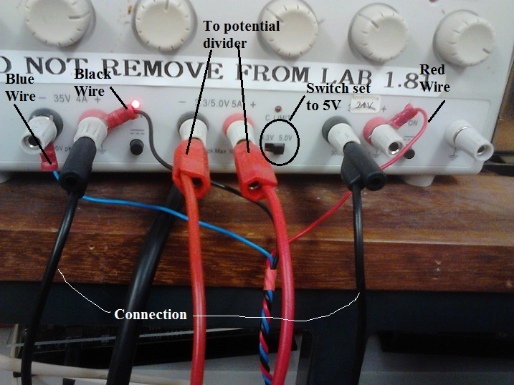
Figure 1: The power supply configuration. A floating supply of 5V is taken from the middle terminals to the potential divider on the analogue tutor board.

- Connect the analogue tutor board from the previous labs. to the data acquisition board (ADC) as in Lab. 3
- Connect the data acquisition board to the training board as in Lab. 3 and connect the power supply into socket 1.
- Attach the USB lead to the board to your bench top PC.
- Wait until it installs the software. Click on the status and it should report the com port number something like com7. You should be able to check it at: Control Panel -> Hardware & Sound -> USB UART.
- Switch on the power supply, go into Start -> EPS programs -> hyperterm. Press cancel, connect using ( com port number) and press configure and enter these parameters : 19200 bits per second, 8 bits, 1 stop bit and no flow control.
- Save this in work directory lab3.ht
- Press ‘ C’ and data should be seen logging to the screen as in Fig. 2.

Figure 2: The logging screen. On the first line after the label 'Continuous', the first number on the left is the reading number with a range 0 -255. The second, fourth, sixth and eighth numbers refer to a channel number 0 – 3 and the other numbers are the corresponding voltage readings for that channel.

Procedure
- Construct the two-opamp configuration differential amplifier as in Fig. 3 using the amplifiers: A1 and A3.

- Connect channel 1 and channel 0 of the ADC to the points indicated on the circuit in Fig. 3. As in Lab. 3, follow this procedure for calibration for both channels:

  - Record the voltage from the channel concerned that appears on the screen and write it in the field, ‘ADC voltage’, in the Table below. To obtain this reading, use the ‘single shot button’
  - Remove the connection to the ADC and Measure the unloaded (by the ADC) voltage at the same point in the circuit using the DMM. Record this figure in the Table below in the field, ‘DMM reading’.
  - Connect the channel in question to the GND on the analogue tutor board and record this voltage in the field, ‘offset’, in the Table below.
  - Calculate, ‘Coefficient’ as:
Coefficient = DMM reading/ (ADC reading – offset).
Write this figure in the field, ‘Coefficient’.
  - Calculate the true ADC reading from:
True ADC reading = ( ADC Reading – OFFSET)* Coefficient.
Write this in the field, ‘Calibrated true ADC reading’.

 | CH0: | CH1:
ADC reading
DMM reading
Offset
Coefficient
Calibrated true ADC reading

- Using component values, calculate the gain. Use the DMM to measure the voltage difference across R13. Compare this with the measured gain that would be derived from measuring of the input voltage difference and the output voltage at channel 0. Note: This type of differentiator draws very current so when measuring the potential drop across R13 with the DMM, it should not make much difference whether the differentiator is connected or not.

Input voltage difference
Output voltage
Measured gain
Calculated gain

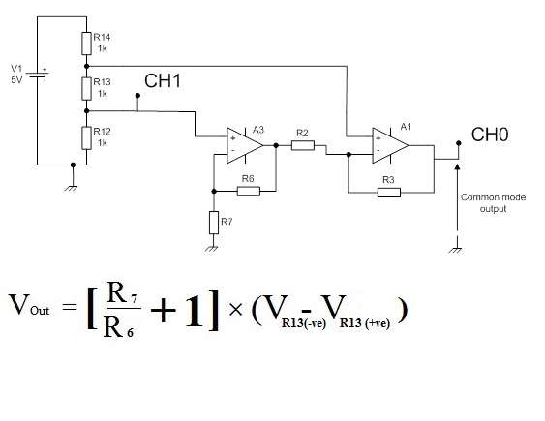
Figure 3: The two-opamp configuration for the differential amplifier circuit with its inputs at the potential difference across R13.

- Since CH1 can also be considered to be at the positive end of R12, estimate the current in the potential divider using this voltage and the resistance of R12 measured with the DMM previously. Note this value in the table below.

Current in potential divider

- Knowing the gain of the differential amplifier and using the measurement from its output at CH0, calculate the resistance of R13. Compare this with the scientific measurement of R13 from the DMM previously and use this to estimate the error in measuring R13 that this method produces.

R13 calculated from differential amplifier output
% error in this value of R13 compared with DMM reading

- Connect the additional components as indicated in Fig. 4 in order to construct a trans-impedance amplifier that will allow for a measurement of current in the potential divider based on voltage. You may need to use Fig. 5 as a guide as the board is missing a critical circuit port near R4.

Figure 4: The two-opamp configuration for the differential amplifier circuit and the trans-impedance amplifier. See Fig. 5 for an idea as to how to wire the trans-impedance amplifier.

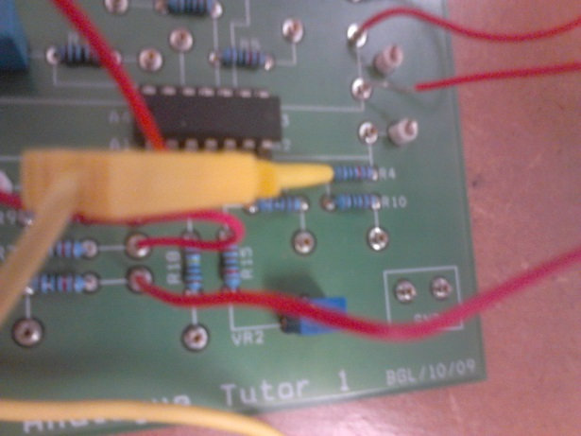
Figure 5: Idea for connecting the negative end of the potential divider to the awkward point near R4.
- Note the trans-impedance of the amplifier at A2. This is given by the component value of R4 but in this context has units of V/A rather than Ω. The circuit diagram for the tutor board can be found in Fig. 6 in the appendix.

Trans-impedance

- Remove the 5V supply from the potential divider. Connect +ve terminal of the potential divider to 3V by using the potentiometer at VR1, i.e., first monitor the output voltage at VR1 using the DMM and adjust with blue screwdriver until 3V is observed, then make the connection to the potential divider.

- Connect CH0 to the output of the differential amplifier and CH1 to the output of A2 the trans-resistance amplifier. Recalibrate CH1 and CH0 by following the now familiar procedure, for calibration and complete the table below for both channels:

  - Record the voltage from the channel concerned that appears on the screen and write it in the field, ‘ADC voltage’, in the Table below. To obtain this reading, use the ‘single shot button’
  - Remove the connection to the ADC and Measure the unloaded (by the ADC) voltage at the same point in the circuit using the DMM. Record this figure in the Table below in the field, ‘DMM reading’.
  - Connect the channel in question to the GND on the analogue tutor board and record this voltage in the field, ‘offset’, in the Table below.
  - Calculate, ‘Coefficient’ as:
Coefficient = DMM reading/ (ADC reading – offset).
Write this figure in the field, ‘Coefficient’.
  - Calculate the true ADC reading from:
True ADC reading = ( ADC Reading – OFFSET)* Coefficient.
Write this in the field, ‘Calibrated true ADC reading’.

 | CH0: | CH1:
ADC reading
DMM reading
Offset
Coefficient
Calibrated true ADC reading

- Knowing the gain of the diff amp, the potential drop across R13 could be calculated from CH 0. Also, knowing the trans-resistance, i.e., a voltage at CH 1 that can now be converted to current, calculate the resistance of R13. As before, compare it with the DMM reading to estimate error in the Table below.

R13 calculated from differential amplifier output and trans-impedance
% error in this value of R13 compared with DMM reading

Appendix: Circuit diagrams for the analogue tutor board and the ADC unit.

Figure 6: Circuit layout reference for the analogue tutor

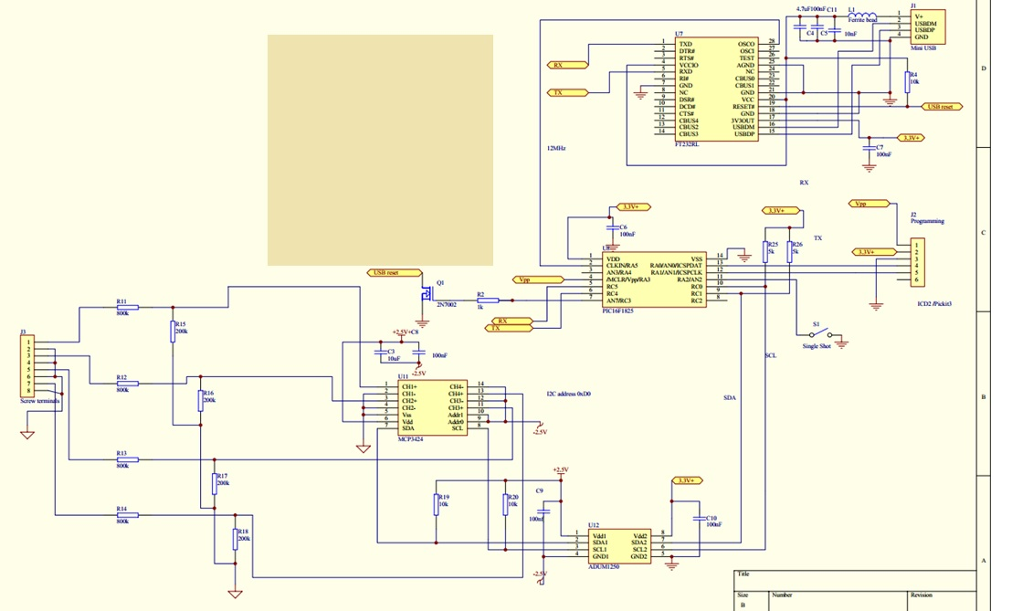
Figure 7: Circuit layout reference for the ADC.

