Electronics and Computer Engineering: Analogue Engineering
Laboratory 3: Data acquisition.

Preparation
- Wire the power supply as shown in Fig. 1 in addition to the way it has been done previously, there will need to be a wire from the +10V terminal on the power supply to the red positive terminal on the analogue tutor board. More about this in step 7.
- Connect the analogue tutor board from the previous labs. to the data acquisition board as shown in the Fig. 2.
- The circuit diagrams for the analogue board and the ADC are at the end of the manual in Figs. 6 & 7.
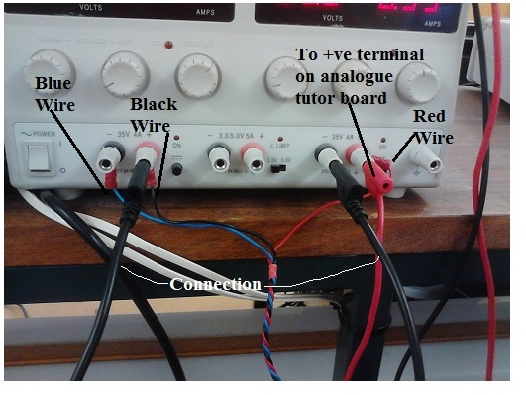
Figure 1: The power supply configuration. No floating supply taken from the middle terminals but instead a red cable comes from the right hand supply to the positive terminal on the analogue tutor board.

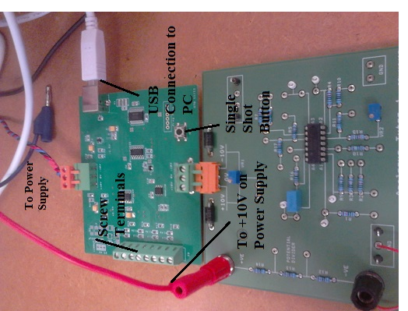
Figure 2: The top device is the Data acquisition board, attached to the bottom training board
Figure 3: How the DAQ is wired internally.
- Connect the data acquisition board to the training board as shown in Fig. 2 and connect the power supply into socket 1.

- Attach the USB lead to the board to your bench top PC

- Wait until it installs the software. Click on the status and it should report the com port number something like com7. You should be able to check it at: Control Panel -> Hardware & Sound -> USB UART.

- Switch on the power supply, go into Start -> EPS programs -> hyperterm. Press cancel, connect using ( com port number) and press configure and enter these parameters : 19200 bits per second, 8 bits, 1 stop bit and no flow control.

- Save this in work directory lab3.ht

- Press ‘ C’ and data should be seen logging to the screen as in Fig. 4.

Figure 4: The logging screen. On the first line after the label 'Continuous', the first number on the left is the reading number with a range 0 -255. The second, fourth, sixth and eighth numbers refer to a channel number 0 – 3 and the other numbers are the corresponding voltage readings for that channel.

- Connect the positive end of the potential divider string R12 – 14 to the +ve 10V and connect the negative end to the training board ground terminal as in indicated in Fig. 2.

- In Fig. 5, on the left, the potential divider that appears between the input to the ADC and the screw terminal. You can confirm this by looking at Fig. 7 and observing that there are potential dividers similar to the one on the left hand side of Fig. 5. The divider quotient for this may be calculated by using the resistor values to calculate the fraction of the voltage seen at the ADC input and dividing the answer by 1, i.e.,

1 / (200 x 10³ /(800 x 10³ + 200 x 10³)) = 5

In reality the ADC also loads this potential divider arrangement by 2.25 MΩ. Repeat a similar procedure for the potential divider on the right hand side of Fig. 5 where it has been loaded by the input impedance of the ADC. Write the answer in the field, ‘Input divider quotient for the ADC with loading’. In the process of doing this, you should calculate the total input resistance between the screw terminal and the ADC, i.e., the total resistance offered by the circuit on the right in Fig.5 between screw terminal and GND. Write this figure in the field, ‘input resistance of the ADC input divider’, field in the table below also.

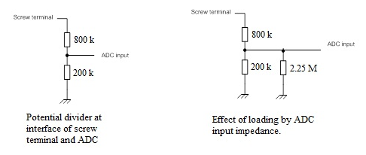

Figure 5: ADC input divider – left, unloaded, - right loaded by the ADC input impedance.

- Using the assumption of the unloaded potential divider quotient, this means that the actual maximum input voltage is 5 x 2.048 Volts. Also, the 16-bit quantiser reserves one bit for indicating polarity thus there are 2¹⁵ levels at its disposal. The error in precision will be the maximum input voltage divided by the number of quantiser levels. Calculate this, round it to the nearest µV and note it in the field, ‘Error in quantiser precision, [µV]’, in the Table below.

- Using the blue screwdriver, wire channel 0 to the junction of R14 and R13.

- Undertake the following procedure:

  - Record the voltage from channel on the screen and write it in the field, ‘ADC voltage’, in the Table below. To obtain this reading, use the ‘single shot button’ in Fig. 2.
  - Remove the wire from the ADC to the junction of R14 and R13 and measure the unloaded (by the ADC) voltage at the junction of R14 and R13 using the DMM. Record this figure in the Table below in the field, ‘DMM reading’.
  - Connect channel 0 to the GND on the analogue tutor board and record this voltage in the field, ‘offset’, in the Table below.
  - Calculate, ‘Coefficient’ as:
Coefficient = DMM reading/ (ADC reading – offset).
Write this figure in the field, ‘Coefficient’.
  - Calculate the true ADC reading from:
True ADC reading = ( ADC Reading – OFFSET)* Coefficient.
Write this in the field, ‘Calibrated true ADC reading’.

- Repeat the procedure in step 11 for channels: 1, 2 & 3 making sure that for Step 11a, you have the appropriate channel wired between the screw terminal and the junction of R14 and R13. Fig. 3 will tell you which channel belongs to which screw on the screw terminal. Step 11b may be omitted having being done once already for this voltage measurement.

Input divider quotient for the ADC with loading
Input resistance of the ADC input divider
Error in quantiser precision, [µV]
 | Ch0: | Ch1: | Ch2: | Ch3:
ADC reading
DMM reading
Offset
Coefficient
Calibrated true ADC reading

- Detach the power supply connection from the +ve terminal of the potential divider string, disconnect the connection from the junction R13 and R14 and measure the resistances of R12, 13, 14 using the DMM.

R12 | R13 | R14

- Re-attach the power supply to the potential divider and connect Ch1 to junction of R12 and R13. Repeat the procedure in step 11 including step 11b for a new DMM reading of the new voltage being measured. Fill in the Table below.

Ch1 at the junction of R12 and R13.
ADC reading
DMM reading
Offset
Coefficient
Calibrated true ADC reading

- Calculate the current in the potential divider by using the measured values of R12, R13 & R14 taking into account that the voltage supply is 10V. Note this in the table below.

- Using the calibrated true ADC reading of the voltage at the junction of R12 and R13 and the measured resistance of R12, calculate the current in the same potential divider as was mentioned in step 15. Note this in the table below and calculate the percentage error. You can assume that the value for the current in step 15 is the more accurate value and the percentage error is thus with respect to that figure.

Current calculation from  step 15 | Current calculation from  step 16 | % error

Appendix: Circuit diagram for the analogue tutor board (Fig. 6) and circuit diagram for the ADC unit (Fig.7).

Figure 6: Circuit layout reference for the analogue tutor

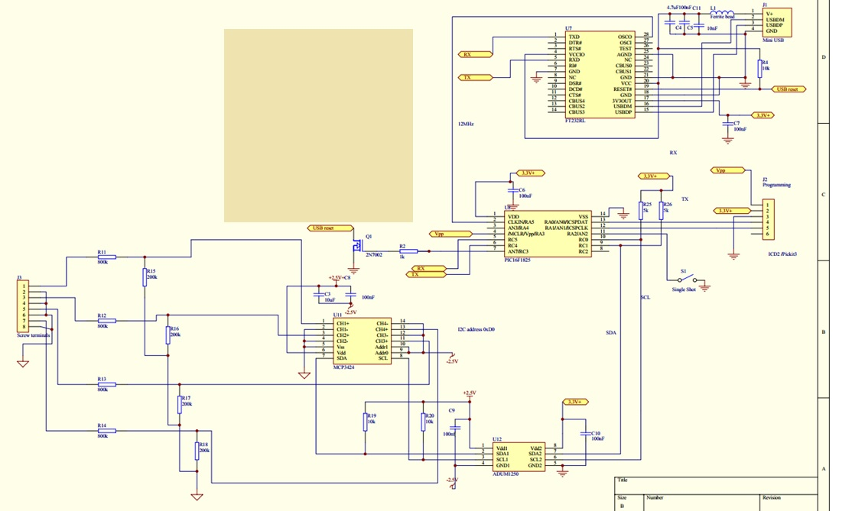
Figure 7: Circuit layout reference for the ADC.

