Electronics and Computer Engineering : Analogue Engineering

Preparation:

Like in the last laboratory session, start by wiring the power supply according to Fig. 1. The circuit layout reference for the analogue tutor is in Fig. 2.

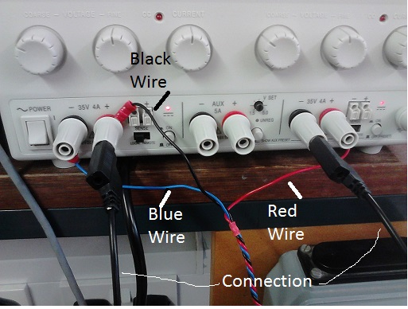

Figure 1: Power Supply wiring configuration.

Figure 2: circuit layout reference for the analogue tutor

Exp 1 The effect of loading on measuring current

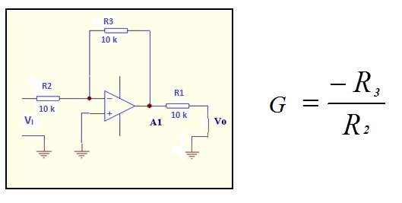

Figure 3: The inverting amplifier with a resistor across the output

(a) Before constructing any circuit, measure the resistance of R1, R2 and R3 precisely using the DMM and set 0.1 V coming from the potentiometer using the blue screwdriver and probes in the same manner as Lab. 1

- Calculate the gain of the non-inverting amplifier, G. Construct the inverting amplifier as in Fig. 3. Measure V_{I} (Probe at same place where voltage across potentiometer is measured – just connect circuit in). and calculate the current, V_{I} /R₂,. Measure V_{O} and calculate the current, V_{O} /R₃.

- The goal of this circuit is to highlight the effect of loading using R1. Are the values for the currents calculated reasonable? Is the gain an issue?

R1
R2
R3
G
V_{I} /R₂
V_{O} /R₃
Is Gain an issue?

Exp 2 The perfect ammeter

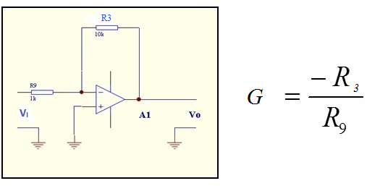
Figure 4 The inverting amplifier as an ammeter.

- Here we measure the output voltage of the inverting amplifier and the aim is to estimate the current that flows in R9. Since V₋ is a virtual ground, this allows for the estimation of the current flowing in R3 (which is a known resistance). Since the current that flows in R3 is equal to the current flowing in R9 (no current flowing into the OPAMP), we can find the latter. This arrangement allows us to measure the current flowing in R9 avoiding loading effects.

- Construct the circuit in Fig. 4, i.e., disconnect R2 and R1 and leave R3 connected and connect the wiper of VR1 to the unconnected end of R9 and measure V_{O} and long with the voltage across R9, i.e. V_{R9} . Based on these measurements, calculate V_{R9} / R9 and V_{O}/R3. Is there a match?

V_{R9} / R9
V_{O}/R3

Additional preparation

Some additional cabling is required as indicated in Fig. 5. These cables are in turn connected to the large potential divider terminals (red power source port to red terminal and black power source port to black terminal) on the analogue tutor board. The switch to the right of the red lead must be set at 3.3 V.

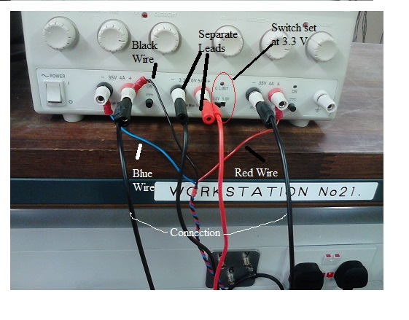
Figure 5: Additional power supply preparation required.

Exp 3 Differential amplifier using a single operational amplifier

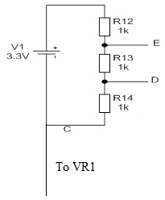

Figure 6: Schematic of the potential divider

- V1, the potential divider on the analogue tutor board, is a floating source (electrically isolated for other supplies) such that it is not referenced to the same ground. While the voltage difference across V1 is maintained constant, the relevant voltage with respect to the circuit’s ground can be adjusted by applying a given voltage at either end of V1. Do not connect C to VR1 yet but measure and record the values of R4, R10, R11 and R15.

- Connect C to VR1 (the blue potentiometer). The voltage from VR1 is the common mode voltage. Measure the voltage between the red terminal (+ve) of the potential divider and ground. Adjust VR1 with screwdriver as before, what happens to the measured voltage?

- A differential amplifier is a type of electronic amplifier that amplifies the difference between two input voltages but suppresses any voltage common to the two inputs. The differential amplifier schematic is given in Fig. 7, compare this with the amplifier, A2, on the analogue tutor board. Is it already constructed? If not make any adjustments.

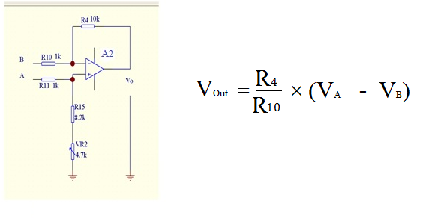

Figure 7: Schematic of differential amplifier at A2.

- Adjust VR1 to give approximately +1V with respect to ground at V2. Connect A and B in Fig. 7 to the two points at the potentiometer wiper, VR1.

- Re-measure VR1.

- Measure the common mode gain. Do this by measuring the increase in Vo, in Fig. 7 and corresponding increase in VR1 and then calculate (change in Vo)/ (change in VR1).

- Now adjust the other blue potentiometer, VR2, to minimise the output voltage, Vo, and measure the common mode gain as before.

- After the adjustment in (g), what happens to Vo when VR1 is varied by +/-1V ? Is there less of a variation? Specifically record Vo when VR1 is 2V and 4V for the table below.

- Using the potential divider connect A and B to the middle resistor, R13, D and E respectively. Connect this network to a floating source, VR1, as before. Measure the output voltage. Does it match with the expected gain of R₄/R₁₀?

- R10 and R11 are both connected to the opamp and the opeamp will force the difference in potential at the positive and negative inputs to zero thus R10 and R11 behave as if in series. Why is the voltage across R13 when connected to A and B not equal to 1.1V, when V1=3.3V and R12 = R13 = R14?
(Hint: R13 seems to be in parallel with the series combination of R10 and R11)

Results
Vo
Expected differential gain
Measured differential gain
Measured common mode gain before adjusting VR2
Measured common mode gain after adjusting VR2
Vo after VR2 adjust
Vo when VR1 is 4V
Vo when VR1 is 2V

- Using a differential amplifier with two op amps.

Figure 6

R2 | R6 | R7 | R13

  - Before power is applied measure precisely the resistances of R2, R6, R7
  - Connect up the differential amplifier as in figure 9
  - Measure all the resistors ( R12,13,14) in the potential divider precisely using the DMM
R12 | R13 | R14

  - Connect the positive terminal (+VE) and -VE to the float source as in exp 3 and measure the voltage precisely with the DMM.
  - Connect the positive input terminal of A3 to the -ve end of R13 and the positive input terminal of A1 to the positive of R13. Measure the output voltage from A1. Knowing the differential gain of this configuration, is this the voltage you expect. The differential gain is found in your notes.
  - Knowing the value of R12, R13, R14 determine the current flowing in the potential divider. Does this match the value estimated using the differential amplifier?

HERE THE DIFFERENTIAL AMPLIFIER PRESENTS VERY HIGH INPUT IMPEDANCE AND THEREFORE DOES NOT LOAD R13

  - Use pspice to investigate the common mode rejection of this differential amplifier. Do this by running the simulation and calculating the common mode rejection ratio in dB. Down load the schematic from vision.
  - If you have time replace R7 with the R15 + Vr2 resistor string and measure the CMRR as in experiment 3.

