Electronics and Computer Engineering

Analogue Electronics B39EE
Lab exercise : Towards measuring resistance

From the lecture on operational amplifiers this exercise seeks to verify the basic equations using an industry standard bipolar operational amplifier LM324.
- Inverting amplifier
- Non-inverting amplifier
- Function generator (includes the integrator).

The ideal operational amplifier assertions are :

- Differential inputs with infinite input impedance.
- Behaviour entirely controlled by feedback elements.
- Single ended/common mode output - sometimes not effected by load
- Output voltage = G* differential input voltage
- Under certain conditions of feedback, the output voltage of the Opamp may output a saturated DC voltage.

Note: the resistor have tolerances of +/- 1% and the capacitors > +/-20%

Instruments:

- Oscilloscope.
- Digital Multi-Meter (DMM).
Note: AC measurement is less accurate than DC.

Preparation:
- Start by wiring the power supply according to Fig. 1. Leave the orange plug disconnected to the green analogue tutor board for the moment.

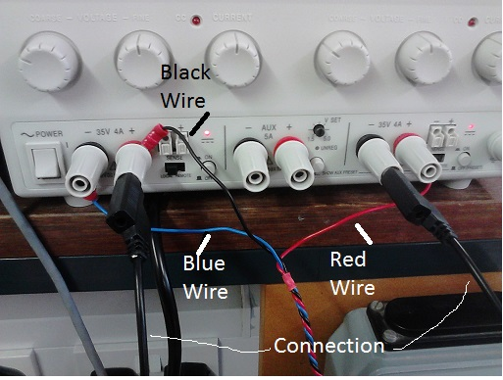

Figure 1: Power Supply wiring configuration.
- Look at Fig. 2. This is a schematic of the tutor board in front of you. There are four opamps, A1-4. Using this schematic, identify on the green tutor board each opamp’s output, each opamp’s inverting input (-) and each opamp’s non-inverting input (+).

Figure 2. Schematic of the green analogue tutor board.
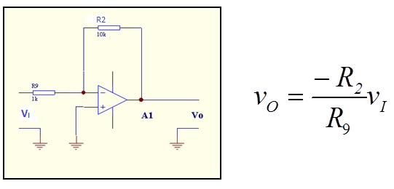
Figure 3: Schematic of an inverting amplifier using A1.

EXP 1. Inverting amp

- Measure the actual dc resistance of R9 and R2 precisely using the DMM. You should achieve 2 or 3 decimal places and calculate the expected gain. The ranges on the DMM allow 0.1 ohms on 4k range and 1 Ohm on the 40k range. Do this before you connect the supply.
- Wire amplifier A1 according to the schematic in Fig. 3. Use the 1k (R9) and 10k (R2) ohms resistors on the circuit board around the amplifier A1.
- Connect the orange socket of the tutor board to the orange plug from the wire connected to the power supply.
- You will notice a blue potential divider just in front of the orange socket. From this is a circuit line going to two silver ports. You will also notice ground (GND) ports and hooks to the right of the potential divider. Measure the voltage between these two points using probes and the DMM.
- Adjust this voltage using the potential divider such that there is around + 0.2V DC ( with screw driver provided).

- Measure its value using the DMM accurately when set, now connect to R9. Note this down on the table. Why is there a difference ? Measure the voltage between the inverting input and ground ( junction of R9 and R2). How close does this comply with ideal operational amplifier assumptions given above ? (Remember that wiring the non-inverting input to GND places a ‘virtual ground’ at the inverting input)

- Calculate the current in R2 and R9 – are they equal ? (Remember: I_{R9} = V_{I}/R9 & I_{R2} = V_{O}/R2) Increase the input to a maximum of +1V – what happens to the output ? Repeat the measurement for an input of +1.5V. Is the gain the same (ratio of output to input voltage) ? If not why not?

- Using a signal generator, connect a 100Hz sinusoidal signal to input A about 0.2V peak to peak voltage, with zero DC offset, amplitude. Measure the output voltage Vo using an oscilloscope. What happens to the gain when the frequency is increased to 100kHz? Make sure the input amplitude is constant at 0.2V peak to peak throughout the frequency sweep.

Inverting Amp results :
R1 Ohms
R9 Ohms
Calculated gain
Measured gain
Current in R1
Current in R9
Gain as frequency increased

EXP 2. Non-inverting amplifier

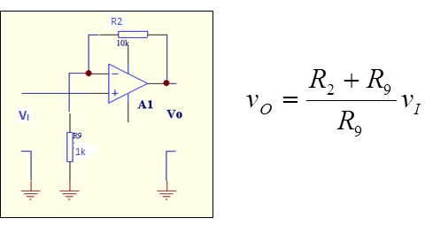

Figure 4: Schematic of a non-inverting amplifier using A1.

  - Connect the amplifier, A1, as in the schematic in Fig. 4 and connect the DC input supply as before while applying around +0.2V DC to the input, V_{I}, using the potential divider, VR1. Using the probes to measure at the output of VR1 with respect to GND. Is there any measured difference in voltage before and after you connected it to V_{I}? (Remember: There is no virtual GND this time and the opamp draws no current).

  - Measure the output voltage, Vo, relative to ground. Does it match the gain calculated from the resistor values (previously measured by the DMM) and polarity?

  - Measure the voltage between the inverting input and ground. How close is this to the input voltage (Remember: the opamp will try to keep the voltages at either input the same)?

  - Measure the resistance value of R18. Re-apply the 0.2V input source via R18 and now measure Vo. Does the output voltage change and what does this tell you about the input resistance of the amplifier (Remember: R18 has reasonably high resistance and the opamp resistance is reasonably high as well but neither is infinite)?

  - Connect the oscilloscope connected at V_{O}, observe what happens if you disconnect A and leave it open circuit (Remember: saturation of opamp would imply V_{O} having being DC at power rail, V_{CC})

  - What happens when you just put your finger on the non-inverting terminal? -- You may have to slightly dampen your finger tip and bear in mind the mains supply of 50 Hz.

Non-Inverting results
Voltage on VR1 wiper before and after connected to the amplifier input, A
Vo
Gain from resistor values ( using measured values)
V inv to ground
Vo with R18 series input resistance
Vo with i/p open circuit
Finger test
Comments

EXP 3 Function generator
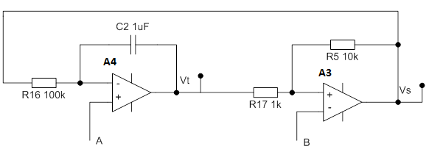

Figure 5: Schematic of a non-inverting amplifier using A4 & A3.

  - Before connecting the circuit above, consider the circuit first. This is a function generator circuit capable of outputting two types of arbitrary waveform depending on where the output is examined, i.e., V_{t} or V_{S}. The circuit at A3 is a Schmitt trigger, which outputs square waves. These are being fed back to the circuit at A4, which is an Integrator circuit. What do you expect the waveform at V_{t} to look like (Remember: What happens if you integrate a square wave or takes its cumulative output)?

  - Measure R16 and then using A4 and A3 connect the circuit up as in Fig 5 with A and B connected to ground. Connect one channel of the oscilloscope to Vt ( output terminal of A4) and the other scope channel to Vs, output of A3.

  - What output do you see at Vt and Vs? How are they related?

  - What happens when you vary the voltage at A from -10 to +10V and ground B, use the wiper of VR1.

  - Now ground A and connect the wiper of VR1 to B. What happens to Vt and Vs

  - The circuit should oscillate at:

R5/(4* C2*R17*R16)

  - Does this match the frequency given by the oscilloscope?

Results
Vs output
Vt output
Vary V_{A}
Vary V_{B}
Frequency of oscillation

